Chapter 6, Problem 6.

The voltage waveform in Fig. 6.46 is applied across a 55-μF
capacitor. Draw the current waveform through it.

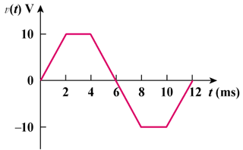

Figure 6.46
For Prob. 6.6.

